Metropolitan
Area
Religious
Coalition of
Cincinnati

30 W. Garfield Pl, Suite 730
Cincinnati, Ohio 45202
Phone 513.721.4843
Fax 513.721.4891
Email marcc@marcconline.com
Web www.marcconline.com

American Baptist Churches USA
Miami Association
Archdiocese of Cincinnati

Baptist Ministers Conference
of Cincinnati and Vicinity

Cincinnati Conference
(Evangelical Lutheran Church in America)

Cincinnati Islamic Community Center

Diocese of Southern Ohio (Episcopal)

Disciples of Christ – SW Ohio

Interdenominational Ministers Alliance

JCRC of The Jewish Federation

Ohio River Valley District
(United Methodist Church)

Presbytery of Cincinnati

Religious Society of Friends

Unitarian Universalist Council
of Greater Cincinnati

United Church of Christ

Volunteers of America
Of Greater Ohio

Chelsea Bennett
President
Nancy Walters
Vice President
Reverend Robert Dye
Vice President
F. Lee Meyer
Secretary
David Tietsort
Assistant Secretary
Robert Ehrsam
Treasurer

Margaret A. Fox
Executive Director
Angela Wright
Office & Technology Manager

April 20, 2018

The Honorable John R. Kasich
Governor – State of Ohio
Riffe Center, 30th Floor
77 South High Street
Columbus, OH 43215-6117
Phone: (614) 466-3555

RE: MARCC Opposes Medicaid Section 1115 Waiver

Dear Governor Kasich,
The Metropolitan Area Religious Coalition of Cincinnati resounded with heartfelt praise and when Ohio’s Governor signed Ohio up for Medicaid Expansion three years ago. MARCC, an interfaith coalition of judicatories (denominations), asks you now not to submit the Medicaid Section 1115 Waiver. It will not expand eligibility, simplify enrollment, or reform care delivery. This new state waiver is being used to impose work requirements on people, who desperately need Medicaid, yet may have a significant challenge finding work.

This work requirement would be difficult for the single parent mom who teeters on the poverty line due to income requirements – she is penalized when she works because she earns too much income ($9 hr.) to qualify for childcare. If she stays home, under the 1115 Waiver she will not qualify for Medicaid.

Under the new requirements, workers will lose health care coverage, people who have lost their job through no fault of their own will struggle to find work. Without health care coverage, they will lose preventive care and will not get care until they need hospital care. It will add to existing deficits in urban Ohio counties – Hamilton, Cuyahoga and Franklin. Hospitals and health care programs that serve the poor and working poor will lose compensation, affecting care and much needed community health outreach programs.

Governor, MARCC is asking you to take right action, to do justice with a compassionate heart, even if it means standing alone. You’ve done it before. We know you can do it again! Please do not sign the Medicaid Section 1115 Waiver if you care about the health of Ohioans.

Respectfully,
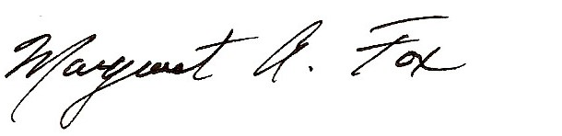
Chelsea Bennett Margaret A. Fox
President Executive Director

